NUvention 2015 Market Concept Brief  
***Due January 25, 2015 EOD***

# Company Overview

Product Name: Breadcrumbs  
Domain Name: breadcrum.bs  
Hypothesis Positioning:

Breadcrumbs is for heavy online content consumers who want/need a more convenient way to keep track of the knowledge they come by on a continuous basis. Breadcrumbs is a browser productivity tool that provides smart online content tracking and organizing. Unlike Evernote, Breadcrumbs offers seamless clipping and content-based display of users’ items without asking users to actively engage in the process.

## How will the team test this product positioning?

We will mainly approach testing through the following steps:

Find out current usage levels of similar tools, such as Evernote.

Validate the need/pain points:

* that people are using workarounds to keep track of their stuff
* that alternatives and workarounds are inefficient and existing tools are hard to navigate and time-consuming
* that people are willing to do something about it
* that people are willing to embrace a new way to find/browse content previously consumed

If there is a need/pain point, then find out the workarounds they currently use.

Interview people about the initial reaction to the concept of an “automated content logging and subsequent topic-based display” (concept testing).

# Market Type Description

Our product addresses an existing market of heavy internet users. Content-heavy users, like college students working on multiple academic and non-classroom projects, will likely adopt Breadcrumbs. With our proximity to many young Internet users who on daily basis face the cumbersome process of bookmarking, clipping and re-searching yet again for the same stuff, our team is better positioned to deliver this product with the most accurate features to address our target audience. Additionally, because we are building the tool from scratch without having to worry about limits of existing platforms, our team can really come up with a game-changing way of organizing browser history. Existing tools are often confusing to navigate, as they often come with too many features that are overwhelming to already divested attention of users. In our preliminary interviews, many students feel that productivity is hindered by the amount of work they need to put into organizing and bookmarking online content. With our product, categorization of content will be done automatically and the organized result will be easily available to users.

# Market Landscape

## Direct Competitors

**Evernote**

Evernote Web Clipper plugin is one of the bigger players in the field that we are entering. Its main strength is that Evernote users can easily sync their clipped web pages to existing notebooks. And the plugin is free. The downside is that not everyone works from Evernote for everything even though they are Evernote users.

**Bookmarking tools**

Diigo <https://www.diigo.com/>

Diigo is a **knowledge management** tool. It offers users annotation, collaboration, and page archive features. It gears towards purposeful users like students and academia in general, which is what we are targeting. It has a free version and paid features. The downside is that the process of saving a link to Diigo is very time-consuming and requires users to input almost everything from tags to location. The new outliner feature allows users to write bullet points for a paper or project and pages can be added directly to these outlines. The problem is that it requires users to move a portion of their writing task to Diigo, which complicates the process of researching because the Diigo tab can easily get lost in the browser and requires more going back-and-forth on users’ side.

Scoop.it

ScoopIt is a platform for curated content. Users can easily share boards and search within the Scoop.It community. One of the strengths for this product is the “suggested content” option to populate a user’s boards based on his/her existing content. The downside is that it does not solve our users’ problem of organizing but it offers a solution for curators to find shareable content on social media. This product also markets to educators to collaborate on specific boards to create a library of knowledge. However, on individual level, it still does not directly address the need to keep track of things that do not seem bookmark-worthy or share-worthy.

**Pinboards**

Pinterest

Pinboards are another breed of competitors to our product since it offers direct visual aid to users when they review their content. Pinterest, as the most popular pinboard product, is a social platform that focuses on shareability, recommendation and discovery. It is not, however, designed for text-heavy content that our target users consume. It is also not commonly used as an tool for academic purposes.

Zotero

Zotero is the only research tool that automatically senses content in web browsers, allowing users to add pages to your personal library with a single click. Zotero collects research in a single, searchable interface and supports PDFs, images, audio/video files and snapshots of web pages. Zotero automatically indexes a user’s library, allowing users to quickly locate an item. However, Zotero uses categorization that is only suited for serious research and might be inefficient for other purposes.

## Complements

Complementarities for Breadcrumbs are those products, services and technologies, when combined with Breadcrumbs, will symbiotically emphasize the importance of each other. As the number of features grows, complementary products will be in order to help users manage, discover and share their content.

* Breadcrumbs would work well with Facebook, Twitter and Google+ as third-party sign-in services. This will allow Breadcrumbs’s sign in and sign up process to be more intuitive and efficient. This will also be necessary to capture information about users across platforms.
* Plenty of personal content sources for our users could potentially be connected to their Breadcrumbs profiles to reach those items not publicly available through a URL. E.g. the user’s Evernote notebooks and notes could be included in the Breadcrumbs profile as just one more type of content or *knowledge*. Same with a user’s Pinterest pins, or Twitter’s posted/favorited tweets.
* A search feature would be needed, which could make sense to initially implement as a plugin from a tried and tested search engine
* Social media share buttons would allow users to share content from their Breadcrumbs profile
* As the features of Breadcrumbs grow into areas like if-this-then-that (IFTTT), mind-mapping and data visualization capabilities will grow in importance, and could be realized through complementary products/plugins.

## Substitutes

Based on interviews with a few dozens of students at Northwestern, we discovered that students almost all have some sort of system to organize their research, but many also expressed that their systems feel “inefficient”.

**Copy-pasting**

Many students choose to create a separate note as a Word document or Evernote. They copy paste a link and a few sentences if necessary. Some prefer writing down secondary sources on a sheet of physical paper. When needed, they go back to the browser and search for the content. Normally these people use a mix of physical books and online sources for their research.

**Google search**

Since Google search is set up in a way that visited pages are bumped up when you repeat a similar search. Many interviewed say when they want to find something they have come across, they simply search for it. However, a few also pointed out that such searches are not necessarily helpful when they cannot remember what keywords to search.

**Bookmarking**

Bookmarking is a common practice. Almost everyone interviewed uses native bookmarking function in their browsers to some extent. Many also save tabs into folders when bookmarking. In addition, most of the interviewees also said they keep dozens of tabs open in their browsers as a way to keep them for shorter-term use instead of bookmarking. Complaints about bookmarking and leaving things open are very similar. Once a person has too many things saved or open, it gets overwhelming to go through all of them again. Things get hidden in a browser’s bookmark bar. Page titles are not easily seen when more than 15 tabs are open. A few people also mentioned keeping tabs open slows their computers.

**Emails, Twitter, etc**

A handful of people interviewed also use Email as a way to save things they see on web. They often email them links so that they know where to find them. A few others use Twitter the same way. They tweet out an article or a site they want to go back to.

## Suppliers/dependent products

Our product is only reliant on having a modern web browser (laptops/desktops) or operating systems (Android/iOS 8+). V1 should be a Chrome extension reliant to collect data.

* Desktop/Laptop: Chrome only
* Mobile: data collection not supported, but social media integration (especially Google) will help solve this problem.

Once we have established and fleshed out features, we would work on extensions for all major web browsers and mobile add-ons for v2.0 (Kango, trigger.io).

We will look into actual Windows or Mac apps last, which are possible, but not likely to be priority as of now.

## Market Map

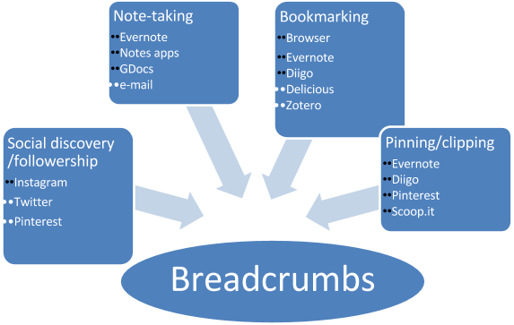

Breadcrumbs provides 2 key benefits over all these:

* Seamless clipping of all content consumed, without active engagement by the user. Not necessary to clip or bookmark anything, and thus no risk of forgetting or mislabeling
* One-stop access to any online item the user has previously seen on any platform, potentially even from a search bar in the browser. No more logging in to different sites to search for different types of content.

### Key questions for customers

* What’s your occupation? --> Screening for students
* What browser(s) do you use? --> Screening for Chrome users
* How do you go about saving content that you want to review or refer to later? What are some pain points in that activity? --> Validating needs/searching for pain points
* Would you be OK with a tool that monitors your online activity exclusively for your own reference? → Testing whether users see this as a severe privacy loss, as a potential threat, or just as something creepy...

# Market Sizing Exercise

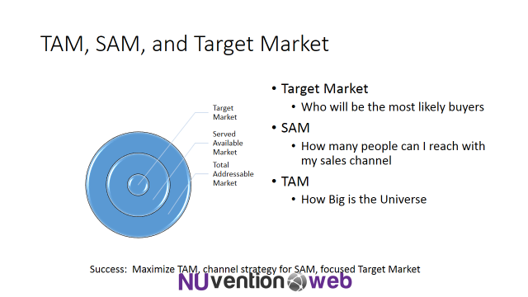

|  |  |  |
| --- | --- | --- |
| Market | Description | Size |
| **Total Available Market** | *“Internet users”* | *Approx. 3bn users worldwide (*[*http://www.internetlivestats.com/internet-users/*](http://www.internetlivestats.com/internet-users/)*)* |
| **SAM** | *“Chrome browser users”* | Approx. 1bn users worldwide (<http://www.businessinsider.com/googles-billion-user-businesses-2014-4>) |
| **Target Market** | *“US college students using Chrome browser”* | Approx. 13M users (21M students * 62% Chrome penetration as of Jan’15) (<http://nces.ed.gov/programs/digest/d13/tables/dt13_105.20.asp> and <http://www.w3schools.com/browsers/browsers_stats.asp> ) |

## Who will the team talk to in order to validate the Target Market?

All three groups are straightforward to identify and interview in the Northwestern University campus just by asking about their online activity, the browser they use, and whether they are students at Northwestern.

* Internet users
* Chrome browser users
* College students using the chrome browser

# Target Market Customer Influence

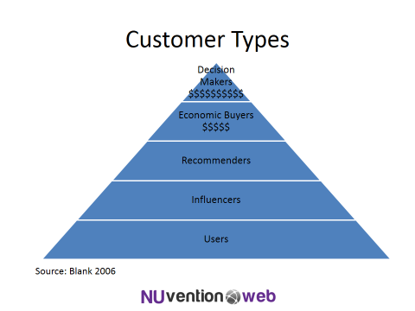

## Users

Content-heavy Internet users are our target users for breadcrumbs. To be more specific, at this stage, our product gears towards multitasking college students who are taking many different classes and involved in many other projects.

## Influencers

Early adopters are surely the greatest influencers. The heavily group-oriented nature of American college education will result in easy spreading of the word from those influencers to their peers, which in turn can become influencers in different workgroups of theirs. Along these lines, it will be key to determine if the MVP should include some group-sharing features that foster this virality for a functional reason.

Campus publications could also be potential influencers, given the focus on college students.

Finally, in the general world of apps and software, powerhouses like Product Hunt funnel user attention and download and could be heavy influencers for adoption of Breadcrumbs. See, for example <http://www.producthunt.com/e/chrome-extensions>

## Recommenders

We envision university staff and faculty to be main recommenders or even prescriptors of our solution. We plan to interview librarians and professors who give students advice on how to organize research materials.

**Economic Buyers**

This product is initially to follow a users business model, to gain mass adoption. Logical next steps in revenue generation could be

* Creating a premium (paid) version, thus embracing the freemium paradigm. Since students are likely unwilling to pay themselves, academic institutions or departments within them could be potential economic buyers, in the interest of student learning and productivity. This would need to be driven by student demand, and that’s why it’s key to secure mass initial adoption. In a further stage, this premium version could target online professionals, which could either pay themselves or have their companies pay for corporate licenses
* Introducing sponsorship as a form of paid promotion in our product. Brands could sponsor items that fall in a specific field of their interest. E.g. Coca-Cola could sponsor all content identified and tagged as related to happiness, thus tainting the background with their red livery in a way that does not hamper user experience.

## Decision Makers

In a couple of the aforementioned business models moving forward, purchase decisions would have to be vetted by purchasing departments at academic institutions or, more generally, at corporations.